Contents
State ID Does Not Have An Expiry Date 2
Pending I-9 Does Not Have An Employment Date 3
Need to Keep New Hire Packet But I-9 Is Not Needed 5
Change the Hire Date on an I-9 6
I-9 Dashboard E-Verify Issues/Nothing Populates When Clicked 7
Document Receipts / I-9 Not Eligible for E-Verify Message 8
Packet Not Created for New Hire/Rehire 9

State ID Does Not Have An Expiry Date
Question | My new employee presented a State issued ID that does not have an expiry date. In section 2, an expiry date is mandatory.
Answer | In section 2, there are two different document choices for a State Issued ID. Select the one entitled “ID Card Issued by Federal, State, Possession or Local Government with Photo.”  This document will give you an option to check a “no expiry date” box on the next screen.  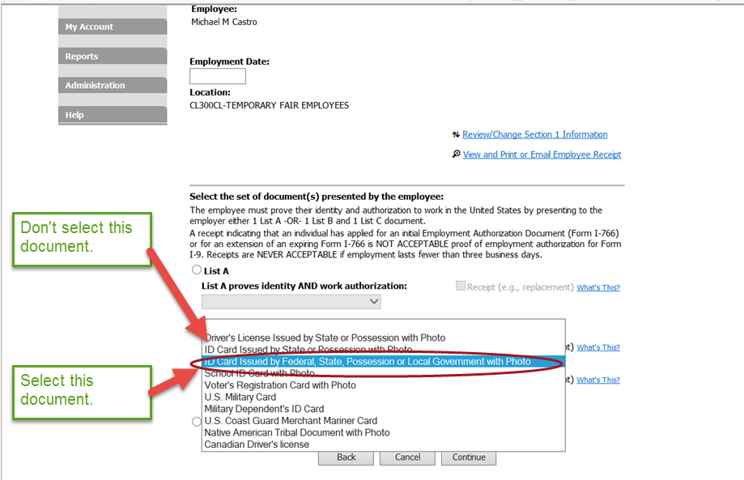

Pending I-9 Does Not Have An Employment Date
Question | Some of my pending I-9s do not have a date of hire.
Answer | When there is no Employment date on the I-9, it is impossible to identify and track completion of section 2 within 3 days of hire.  To view any I-9 your agency may have in such a case, go to the I-9 Management Dashboard and click on the “pending” link.  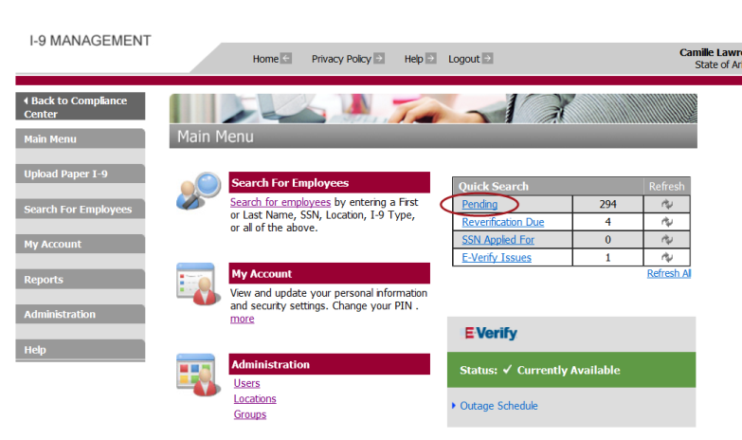  The list of future hires who have completed section will appear (you will only see your agency’s information). There should be an “Employment” date for every individual on that list. Section 2 of the I-9 must be completed 3 days after the employment date at the latest.  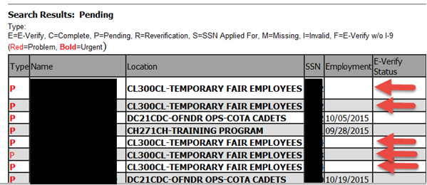  Click on the name of an individual who does not have a date in the “Employment” field.  Click on “Review/change Section 1 Information.”  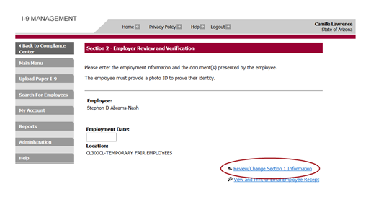

Enter the new hire’s first day of work here:
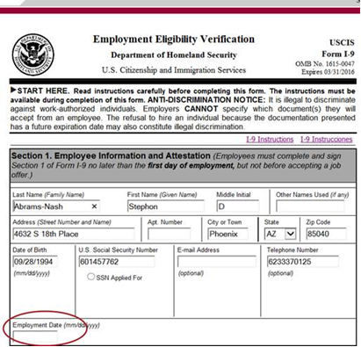

Click on “Continue” and log out of the case. The hire date will now appear in the Employment field.

Need to Keep New Hire Packet But I-9 Is Not Needed
Question | An individual filled out a new hire packet but it turns out that the I-9 was not needed. How do I remove it from the Pending case?
Answer | Any I-9 that is not completed after 60 days from the date of employment is automatically purged.

Change the Hire Date on an I-9
Question | The hire date for my candidate has been changed. The I-9 appears in my pending I-9s but it looks like section 2 is past due because the hire date is incorrect.
Answer | - Look the employee up through the Compliance Center.  - Click on the employee’s name.  - Click on Click on “complete I-9.”  - Click on “review/change Section 1 Information.”  - Change the Employment Date to the correct date in section 1.  - Click on Continue.  - Then don’t do anything else and click on “back to compliance center”  - The hire date is now changed.

I-9 Dashboard E-Verify Issues/Nothing Populates When Clicked
Question | The Quick Search I-9 Dashboard shows that I have items due or E-Verify issues but when I click on the link nothing populates.
Answer | - Before you use this Dashboard, always click on “Refresh All” at the bottom of the table.  - The number that appears in “Pending” is for your agency only.  - All the other items (Reverification Due, Receipt Due, E-Verify Issues) show the statewide numbers. Your agency may not have any I-9 in that category. Click on the link; if nothing populates, no action is required on your part.  * SSN Applied For is not used.  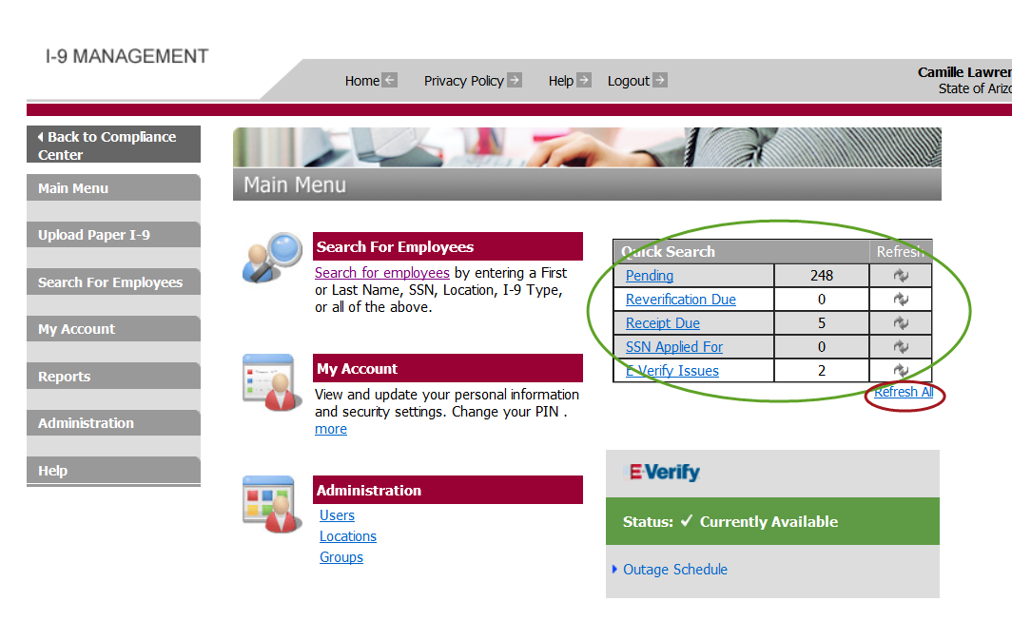

Document Receipts / I-9 Not Eligible for E-Verify Message
Question | I verified section 2 with the documents the employee presented and I got a message that the I-9 is not eligible for E-Verify.
Answer | - This message appears when a new hire presents a document receipt.  - The I-9 does not go through E-Verify until the original document is produced.  - When the employee presents the original document, go back in the Compliance Center to pull up the I-9 and click on “Receipt Update”  - Enter the information about the document the original.  - Close the I-9 as usual when the “Employment Authorized” message is received.  - I-9s for employees who presented receipts can be tracked on the I-9 Dashboard, Quick Search box.  - Don’t forget to click on “Refresh All.”  - Remember that the number next to “Receipt Due” is for the entire state  - Click on the “Receipt Due” link.  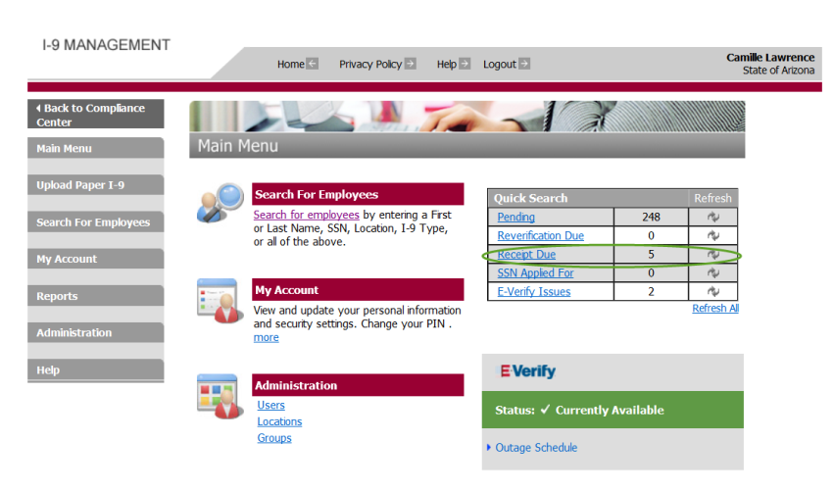  - If your agency has any employees in that category, their name will populate.  - The employee has 90 days from the Employment date to produce the original.  - An Excel spreadsheet of this information can also be exported and it will show the actual deadline.  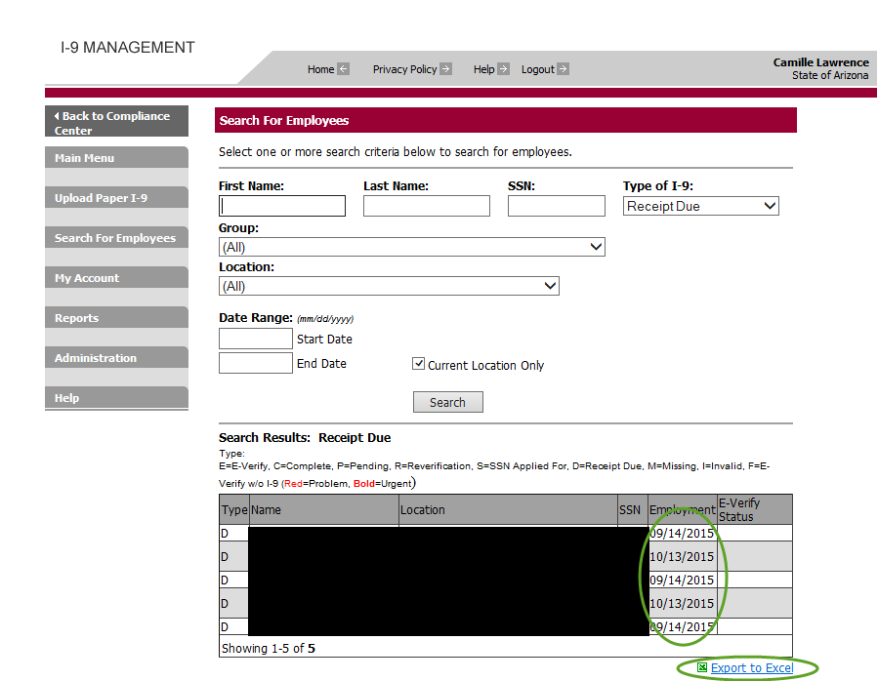

Packet Not Created for New Hire/Rehire
Question | I thought I created a packet for a new hire but I can’t find it.
Answer | - The packet must contain an e-mail in Talent Acquisitions on the “Hire” action form. This is the form that the Recruiter completes when pushing the hire to HRIS.  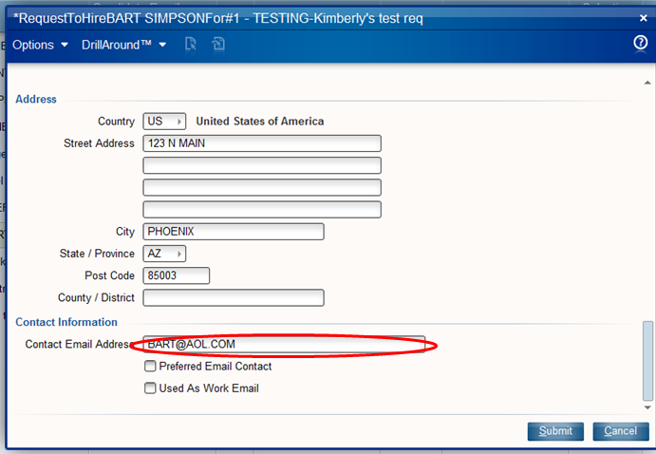  - The hire date (Start Date) in Talent Acquisition of the new hire/rehire must be today’s date or in the future. The hire date cannot be in the past or the new packet will not be automatically created in Onboard AZ.  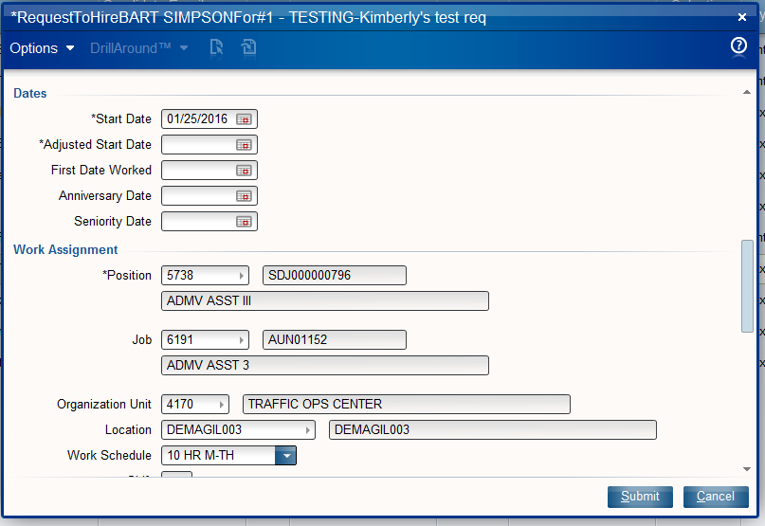  - Packets are created each night and the corresponding email is sent to the new hire/rehire. It is not created immediately after the hire action/EIN is created. If you have entered a hire action during the day, the packet won’t exist until that evening.  - If there is an urgent need to create a packet immediately, you may create a manual packet in Onboard AZ, however, you must use the EIN as the login (do not click auto-create user name) so the data will stay in sync. If the hire action is later entered in Talent Acquisition after your manual packet was created, a duplicate packet will be created in Onboard AZ and you will need to cancel one of the packets in Onboard AZ.  - Please note that packets are not created automatically for Interagency Transfers at this time.

