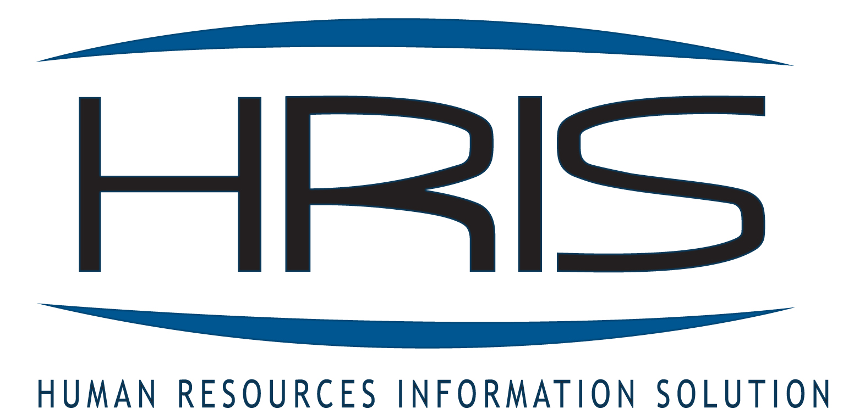

HRIS Agency Table Maintenance Process

General information:
HRIS contains data submitted by agencies to define their structures for Process Levels, Departments, User Levels (check locators) and Position (Geographic) Location Codes. If there are changes to these items, HRIS Tables must be revised before any activities related to that change can be processed. The following information outlines the process for submitting HRIS Agency Table Maintenance changes.

HRIS has established a mailbox specifically for the purpose of updating these files. Agencies are asked to submit requests directly to the HRIS Table Update Mailbox.
hristableupdate@azdoa.gov

While these requests will be processed as soon as possible, requests should be submitted in advance of urgent situations. Table Maintenance requests are normally completed within 48 hours. Higher volume requests will take longer to process.

Specific Information:

AGENCIES: Instructions, formats and links have been posted on the HRIS website at: http://www.hr.az.gov/HRIS/pdf/training_manuals/table_maintenance.pdf

- This process is used for maintenance to Process Levels, Departments, User Levels and Position (Geographic) Location Codes only.
- • It is critical that the agency completes the configuration document spreadsheets in the format provided on the HRIS Forms website examples, and submit them to the HRIS Table Maintenance Mailbox.
- • Configuration documents that are received in any other format will be returned to the agency for revision. This includes additional formatting added by the agency.
- • If this action involves the movement of positions within a System A agency, a request for this movement must be made through ADOA Classification & Compensation.

Communication:
Agencies will be notified by email within 24 hours after Table Maintenance requests have been completed.

Email to: hristableupdate@azdoa.gov

HRIS Agency Table Maintenance Authorization Form

Effective Date __________ Agency _____________________

The following individuals have authorization to make any additions or corrections to the HRIS Table Maintenance setup for all Process Levels, Departments, User Levels, and Position (Geographic) Location codes within our agency. This authorization shall remain in effect until a revised form is received.
The employees authorized to make these changes have reviewed the HRIS Table Maintenance Process and are familiar with the setup of the HRIS system. Table Maintenance additions and changes must be submitted in the format provided on the HRIS Forms website.

Authorized employee _______________________________ Signature _____________________________

Email ___________________________________________ Telephone ____________________________

Authorized employee _______________________________ Signature _____________________________

Email ___________________________________________ Telephone ____________________________

Authorized employee _______________________________ Signature _____________________________

Email ___________________________________________ Telephone ____________________________

Deletions: Name ______________________________________________ Date ______________________

Name ______________________________________________ Date ______________________

Approvals: (both signatures are required)

HR Manager __________________________ Signature _________________________

PR Manager __________________________ Signature _________________________
HRIS USE ONLY

